Lab Tasks 1-6
Lab 1
- What is Software Crisis?
The challenges in software development, especially in the late 1960s, when projects frequently ran over budget and deadline, and the delivered software was often unreliable, difficult to maintain, and did not meet requirements.
- What is Software Engineering?
The application of engineering principles to the design, development, testing, and maintenance of software systems
- What is software quality?
The degree to which a software product meets specified requirements and customer expectations, encompassing attributes like functionality, reliability, performance, usability, and security
- What are the two aspects of software cost?
Development Cost: This includes all expenses related to the initial creation of the software, such as planning, design, coding, testing, and deployment. This is often the initial, upfront investment
Maintenance and Support Cost: These are the expenses incurred after the software has been delivered and deployed.
- What are the three elements of Software Engineering?
The three core elements of software engineering are methods, procedures, and tools.

Task1
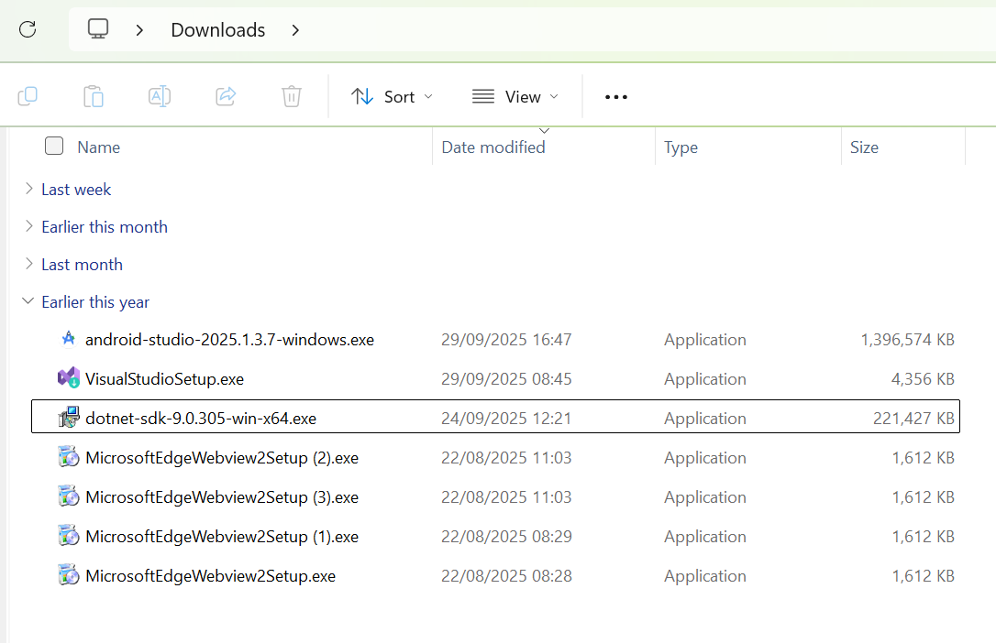
The following screenshot show that I have installed android studio on the 29/09/2025

Task 2
I have explored the UXL files in android studio and learnt how to use in when creating my app and what I does.
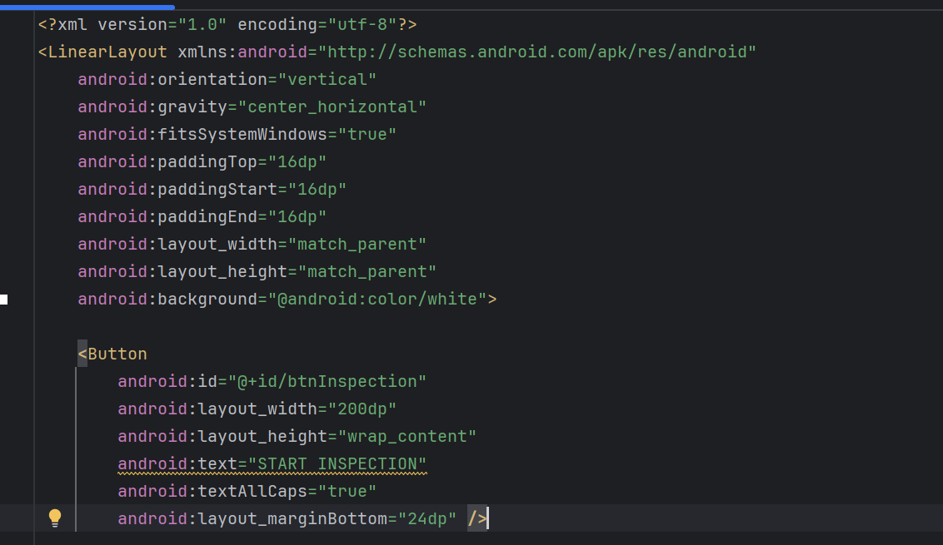
Task 4
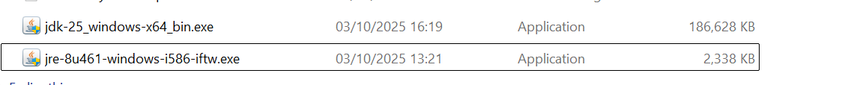
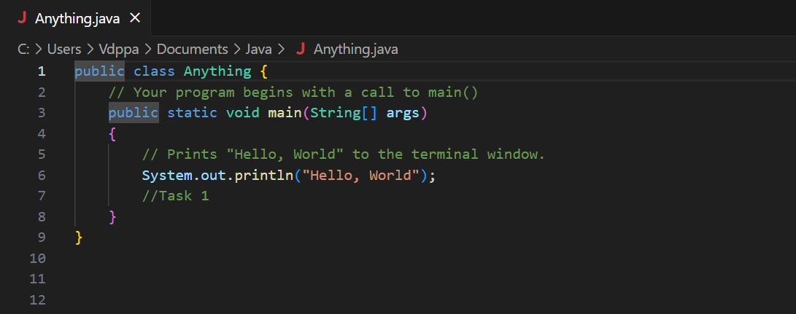

Lab 2
- What is the software development process or software development life cycle (SDLC)
There are several stages of the software development cycle
- Planning
- Requirement analysist
- Design
- Implementation
- Testing
- Deployment
- Maintenance
- . How many phases are there in a general SDLC, and what are they?
There is seven stages of the software development life cycle
- Planning
- Requirement analysist
- Design
- Implementation
- Testing
- Deployment
- Maintenance
- What are SDLC models?
SDLC (Software Development Life Cycle) models are frameworks that structure the process of building software, guiding it through a series of phases like planning, designing, developing, testing, and deployment

- What is the name of the international standard for SDLC models?
SO/IEC/IEEE 12207
- Why is feasibility analysis important, and what aspects should be considered during a feasibility analysis?
feasibility analysis is important because it helps determine if a project is viable and worth pursuing, preventing investment in ideas that are unlikely to succeed.

- Why is requirements analysis important?
Requirements analysis is important because it ensures that a project aligns with stakeholder needs by defining and documenting requirements early, which reduces rework, costs, and misunderstandings later on.
- How should we understand Stakeholders?
To understand stakeholders, identify everyone who is impacted by or can influence a project, then analyse and categorize them based on their interest and influence to prioritize engagement

- What is a use case?
A use case describes a user interaction with a system or a product it process to archive a soften goal

- What is an event flow
A event flow is a sequence of orders of events that unfolds to describe a timeline of an organised event of attendees or the path an event takes through a system.

10. What are the differences between functional and non-functional requirements
Functional requirements define what a system must do its specific actions and features), while non functional requirements define how well it must do it (its qualities, constraints, and attributes
- What should good requirements look like
Good requirements are clear, concise, correct, and complete, meaning they are unambiguous, easy to understand, accurately reflect the business needs, and cover all necessary details. They should also be testable so it's possible to verify if the requirement has been met. Additionally, they need to be feasible, consistent, and modifiable.

Task 1
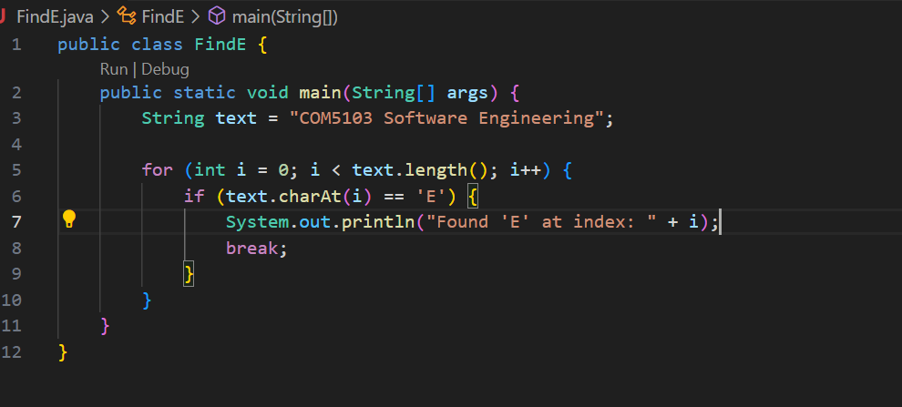
Task 2
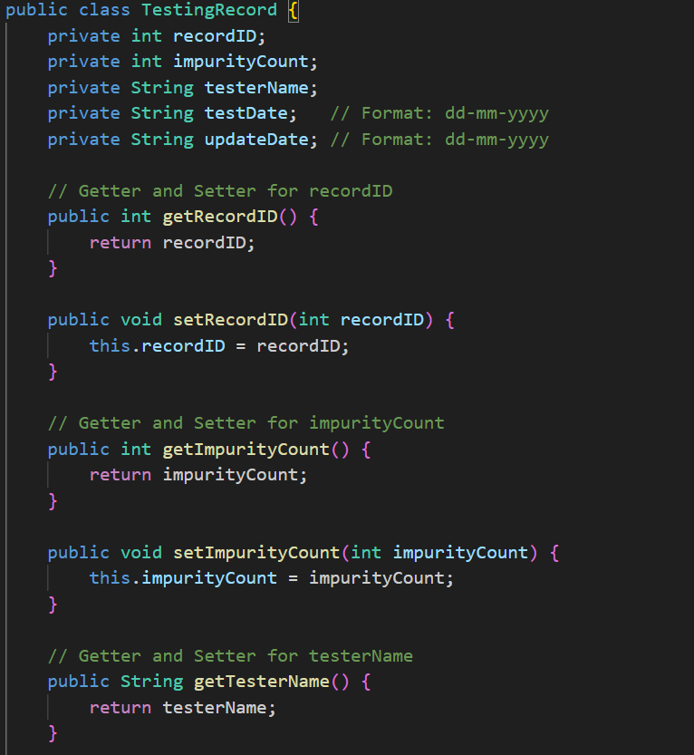

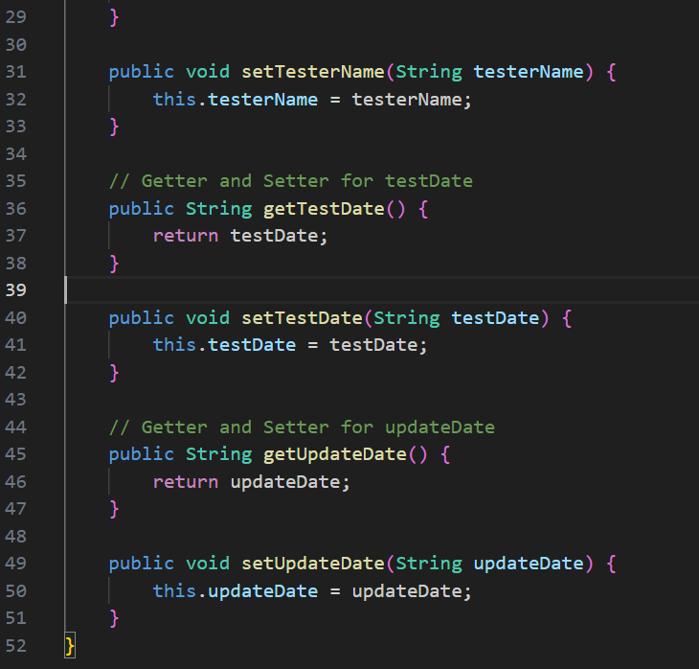
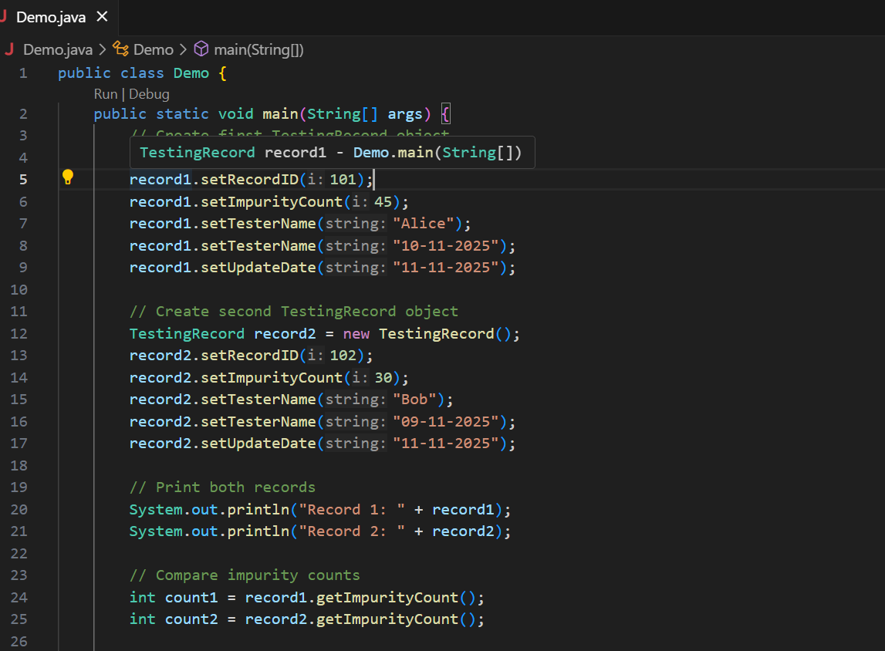
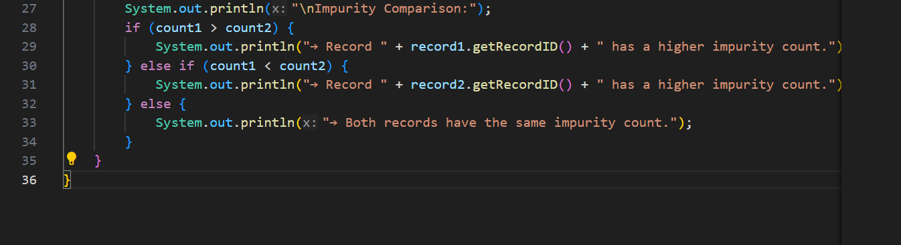

Lab 3
- What are High-Level Design (HLD) and Low-Level Design (LLD)? And how do they differ in terms of scope, detail, and purpose?
High-Level Design (HLD) focuses on the overall system architecture, defining major components and their interactions, while Low Level Design (LLD) focuses on the detailed implementation of each component, including specific algorithms and data structures.
- What key things should be specified in an HLD?
A High-Level Design (HLD) document should specify the overall system architecture, its major components, how they interact and the data flow between them, without delving into specific implementation details.
- What is the difference between UI design and UX design?
UI (User Interface) design focuses on the visual and interactive elements of a product, such as buttons and colours, while UX (User Experience) design focuses on the overall journey a user has with a product, including its functionality and how it solves their problems.
- What are the goals of UI/UX design?
The main goals of UI/UX design are to create a product that is both visually appealing (UI) and easy to use (UX), ensuring it meets user needs and business objectives
- What are the four core principles of effective UI/UX design?
Consistency, Clarity/Simplicity, Usability/Accessibility, and Feedback.
- What are the general steps involved in the UI/UX design process?
The general steps in the UI/UX design process are to define objectives, conduct user and business research, analyses the findings, create wireframes and prototypes, and test and iterate based on feedback.

7 . What are the differences between structured data and unstructured data?
Structured data is organized in a predefined schema with a consistent format, making it easy to search and analyses using tools like SQL. Examples include data in an Excel spreadsheet or a relational database. In contrast, unstructured data lacks a predefined format, making it more complex to process, and includes data like photos, videos, emails, and social media posts.
- What are the general steps in database design?
The general steps in database design involve requirement analysis, creating a conceptual model (like an Entity Relationship diagram), designing the logical model by organizing data into tables with primary keys, and then developing the physical model which specifies how the database will be stored
Task 2,3
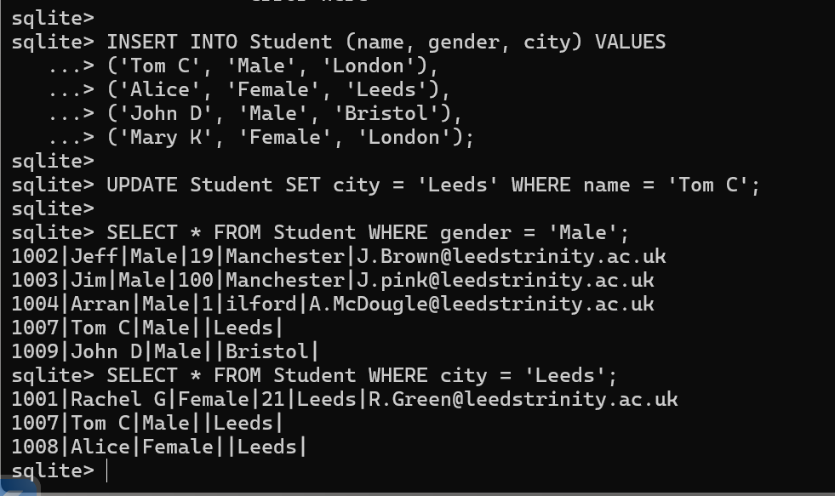

Task 4
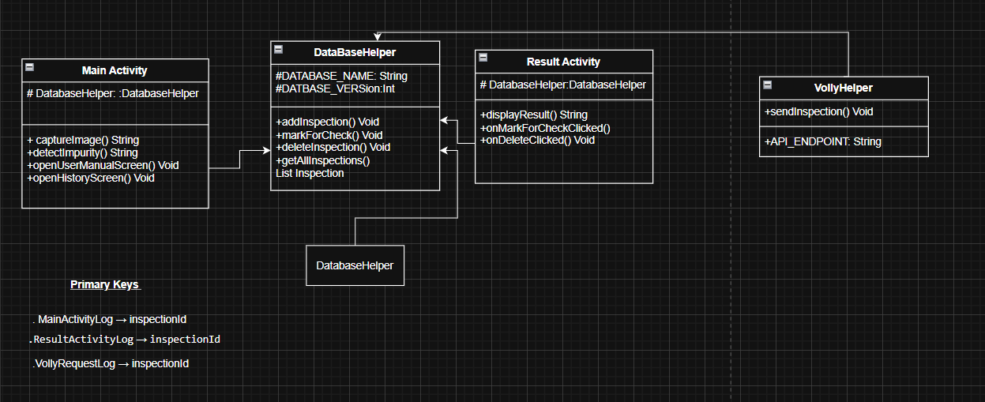
Lab 4
- What does good code look like?
Code with good comment, no errors, and in consistent format
- What components should be considered in coding standards, and how are they applied in software development?
code style, naming conventions, and documentation for consistency, along with security, testing, and error handling for reliability
- What are the four common case styles used for naming in software development? How do we decide which style to use when naming classes, methods/functions, variables, constants, Boolean flags, database tables, and columns?
The four common case styles are camelCase, Pascal Case, snake case, and kebab case
- What are the key components of coding style, and how would you apply them in your programming practice?
- Use white space generously
- Uses spaces rather than tabs so that the code displays doesn’t depend on the reader tab settings
- Use indentation to indicate block structure

5.Why do we need encapsulation and how?
We need encapsulation to protect data, enforce control over access, and improve code organization, flexibility, and reusability
6 Why do we need inheritance and how?
We need inheritance for code reusability, creating new classes from existing ones to avoid repeating code

- Why do we need polymorphism and how?
We need polymorphism to write more flexible, reusable, and maintainable code
Task1
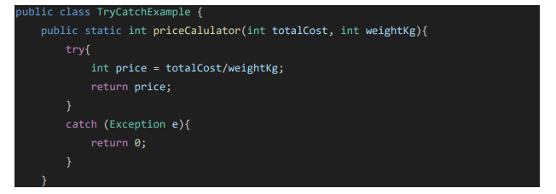
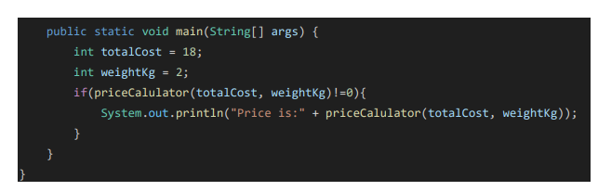
The class has several coding issues. The method name is misspelled and should be corrected for clarity. It catches a generic Exception, which is too broad using a specific one like ArithmeticException is better. Returning 0 silently may hide errors; logging or throwing a meaningful exception is preferred. Input validation for weightKg is missing, risking division by zero. Lastly, the formatting and indentation need improvement for better readability.

Task 2
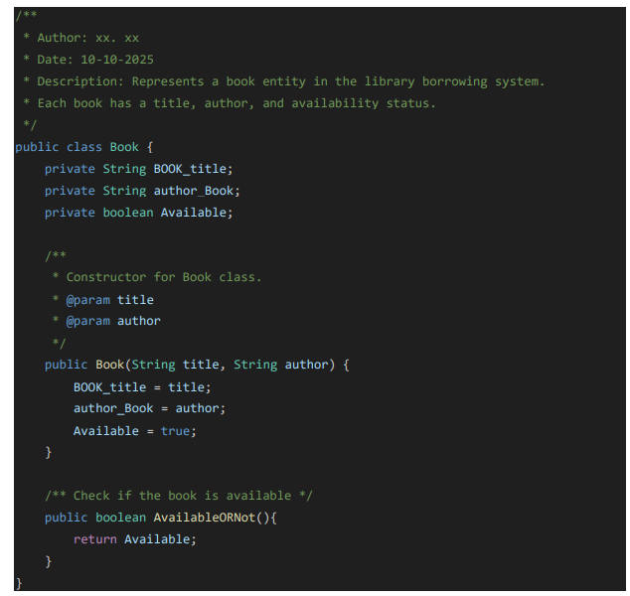
The code violates standard Java naming conventions. Field names like , and should use camelCase, starting with lowercase letters and avoiding underscores or uppercase prefixes. Similarly, the method should be renamed to for clarity and consistency. These changes improve readability and align with Java best practices.

Task 3
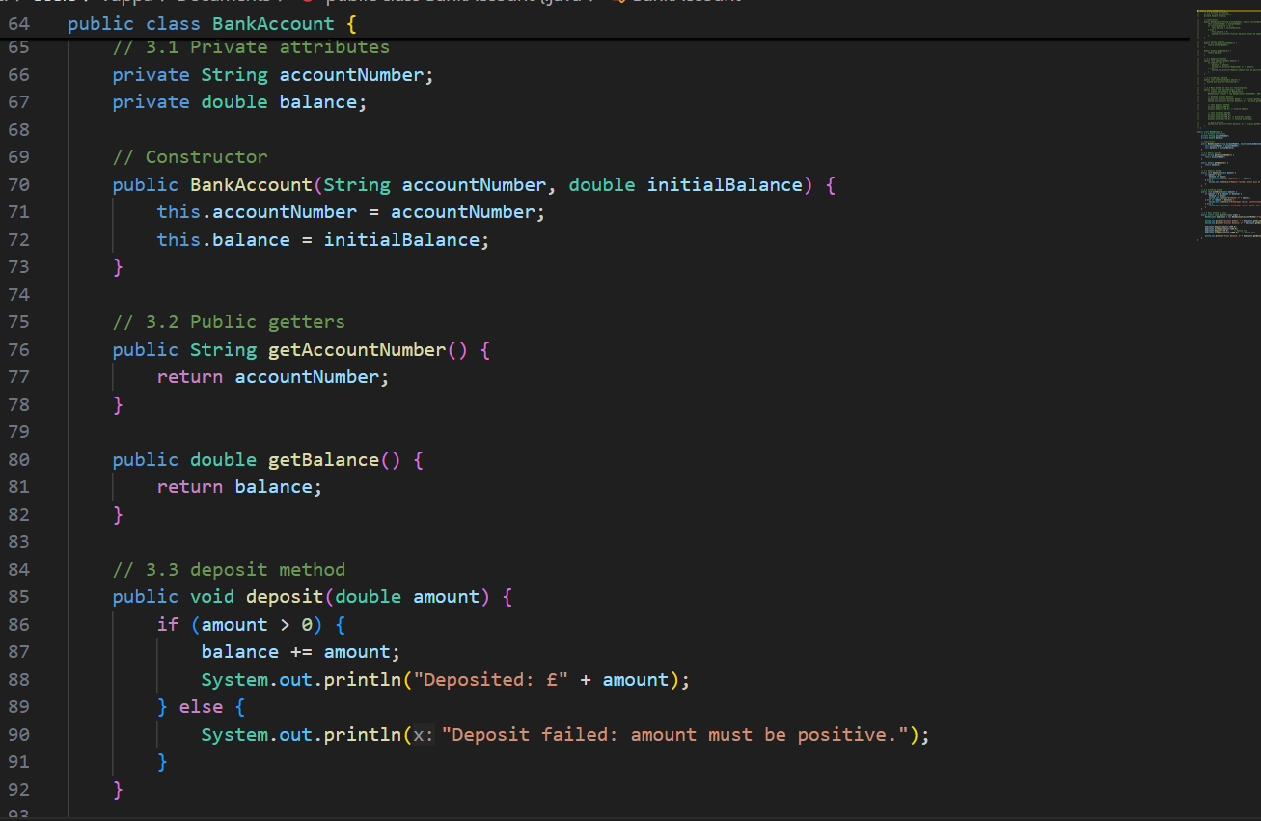

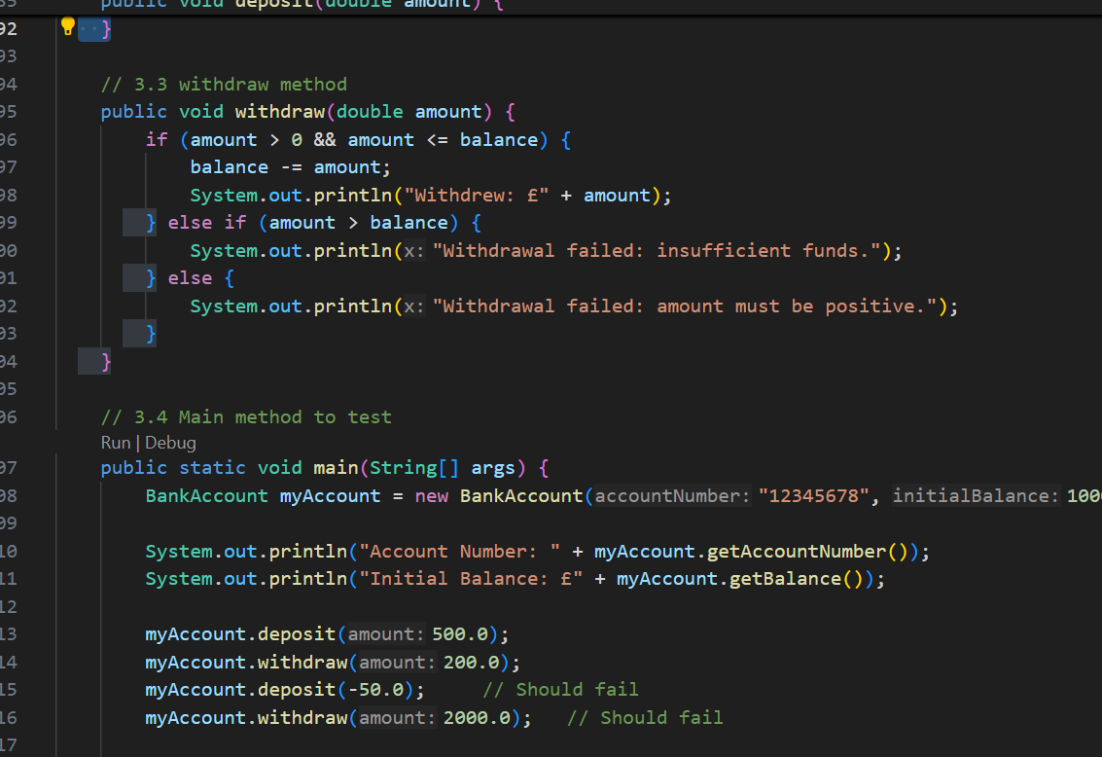
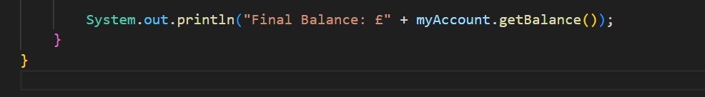
Task 4
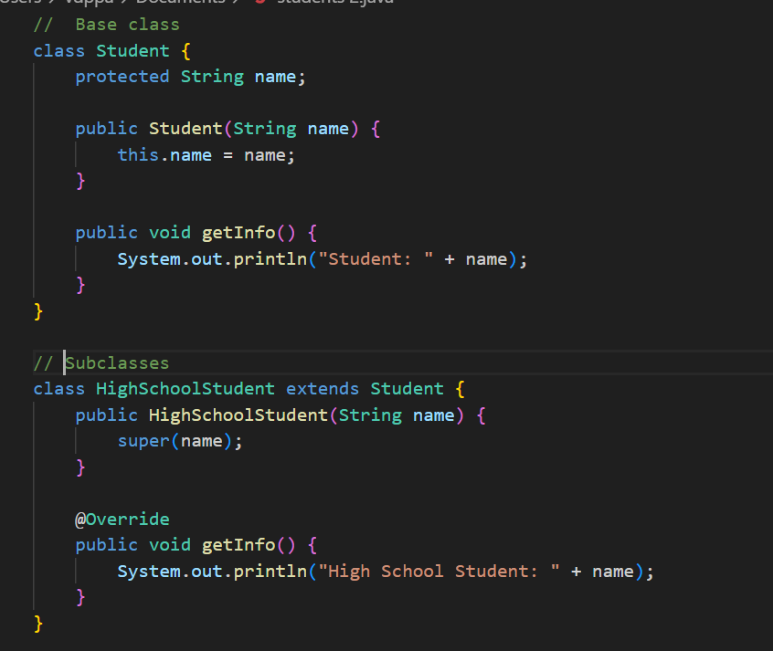
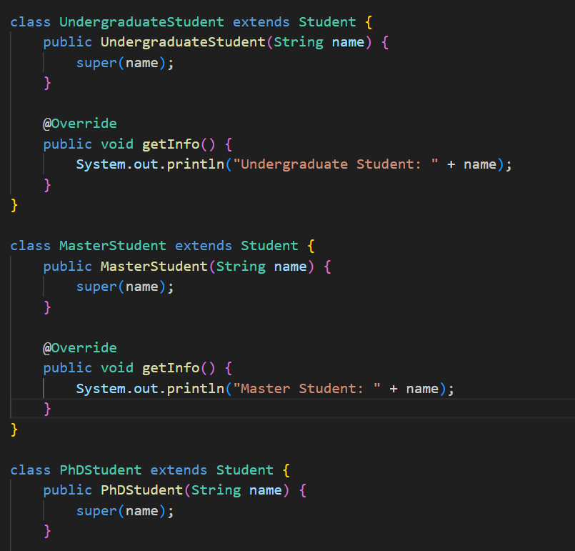
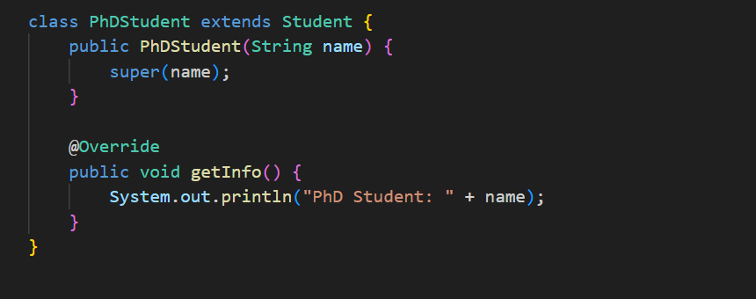
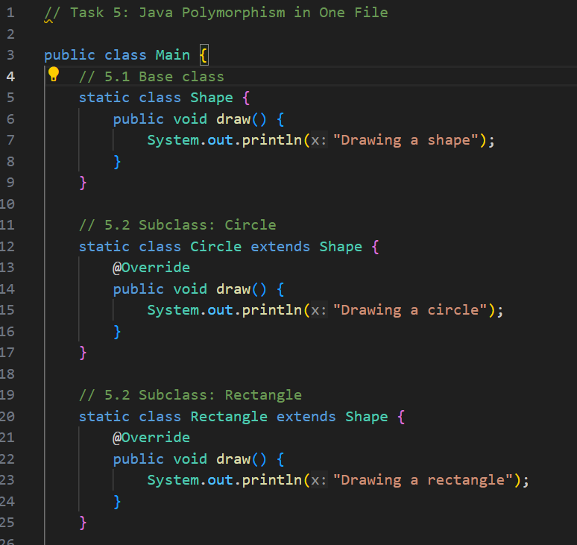
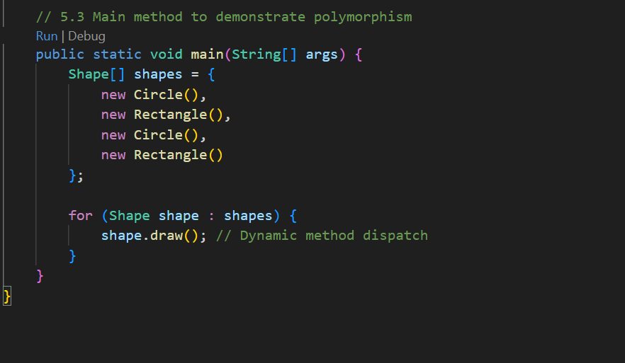

Lab 5
Task 1.1
Noun Phrase | Potential class
Room | Room
Room Number | Attribute of room
Room Type | Attribute of room
Price | Attribute of room
Customer | Customer
Name | Attribute of customer
Contact details | Attribute of customer
Booking | Booking
Booking reference/ID | Attribute of Booking
Check-in/check-out dates | Attribute of Booking
Staff member | Staff member
Staff role | Attribute of staff
Room status | Attribute of room

Task 1.2
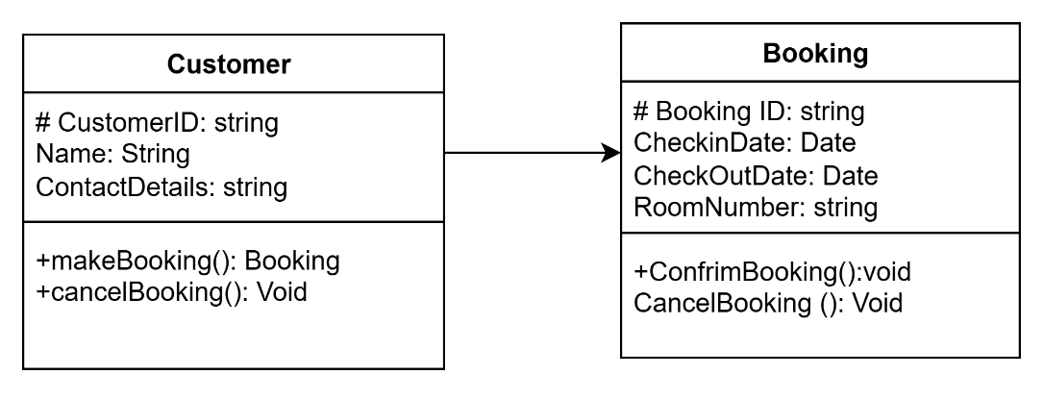

Task1.3
A Customer can have multiple Bookings. Each Booking is associated with one Customer.
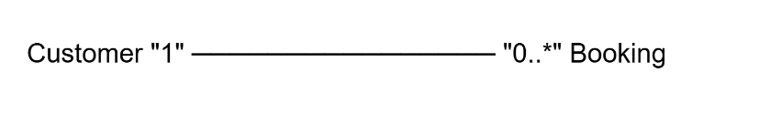
Task 2
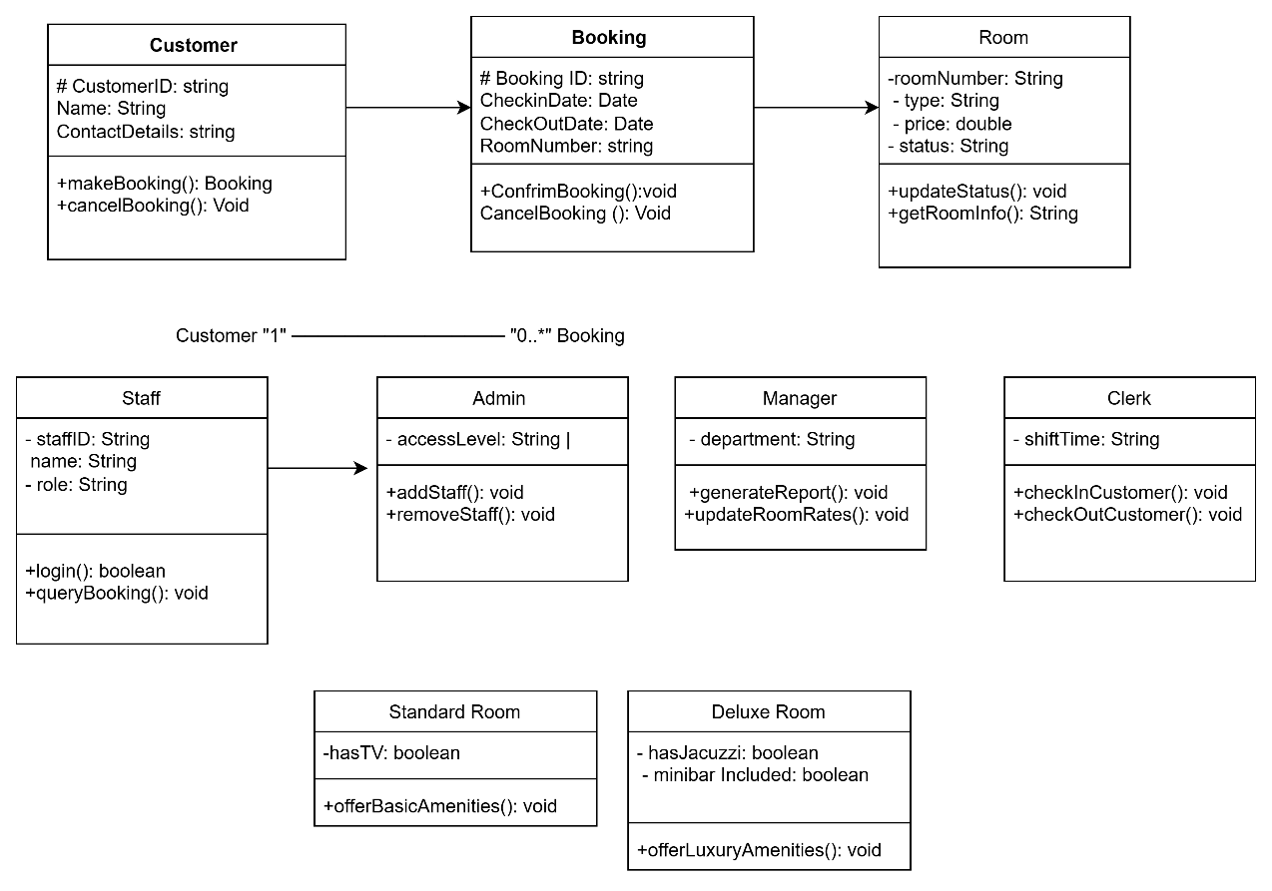

Task 3
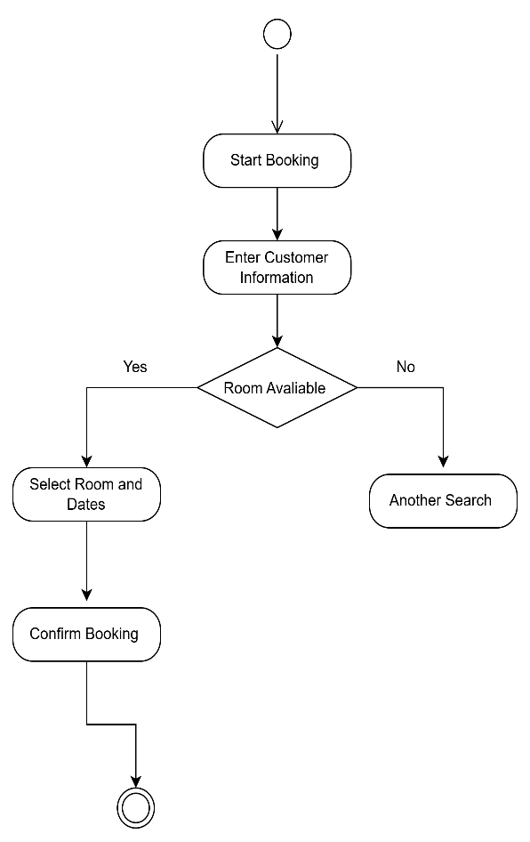

Task 4
Actor | Description
Customer | Books and cancels rooms
Staff | Manages rooms and queries bookings
Admin | Manages staff account
Manger | Generates reports and updates pricing
Clerk | Handles check-in/check-out

Use Case | Actors involved
Make Booking | Customer
Cancel Booking | Customer
View Booking | Staff, Customer
Add Room | Staff
Delete Room | Staff
Update Rooms Statues | Staff
Login | Staff
Add Staff | Admin
Remove Staff | Admin
Generate Reports | Manger
Update Room rates | Manger
Check-in Customer | Clerk
Check-out Customer | Clerk

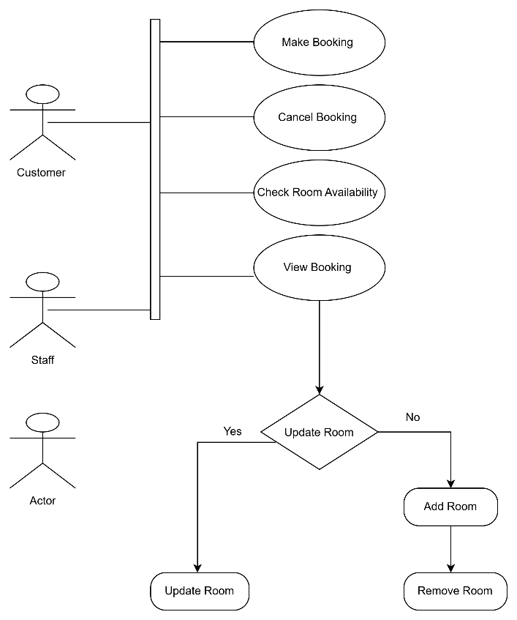
Lab 6
1.How can we describe a use case in detail?
A use case is described in detail by outlining the actor, their goal, the basic success path, and any alternate or exception paths for how a user interacts with a system to achieve that goal.
2. What are the key features of a good use case description?
A good use case description includes key elements like the use case name, actors, pre conditions, post conditions, and a detailed normal flow of events.
3. Which UML diagram is used to represent the different states an object can have, and how is it illustrated?
A UML state machine diagram is used to represent the different states an object can have and is illustrated with rounded rectangles for states, arrows for transitions, and events as labels on the arrows
4. Which UML diagram is used to show how objects interact and collaborate within a specific scenario, and how is it represented?
A sequence diagram is used to show object interactions within a specific scenario by depicting the sequence of messages exchanged over time. It is represented with objects arranged horizontally as vertical lifelines, and messages are shown as horizontal arrows between these lifelines, ordered chronologically.
5. What is CRC and what is it used for?
What is a cyclic redundancy check (CRC). CRC is an algorithm used to detect errors in data transmission
Task 1
Use Case | Actor Involved
Login | System User, Administrator
Submit Data | System User
View Dash board | System User, Administrator
Generate Report | Administrator, External Auditor
Mange User | Administrator
Export Data | Administrator
Review Logs | External Auditor

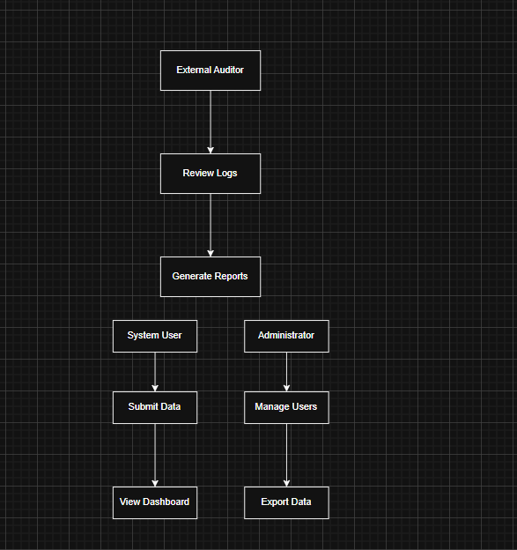

Use Case Description
Make Booking:
Use Case Name: Make Booking
Actor: Customer
Pre-conditions:
Customer must be logged into the system
Rooms must be available for the selected dates
Post conditions:
A new booking is created and stored in the system
Confirmation is displayed to the customer
Normal Flow:
1. Customer logs into the system
2. Customer selects desired check-in and check-out dates
3. System displays available rooms
4. Customer selects a room and enters booking details
5. System validates the input and creates a booking record
6. Booking confirmation is shown with reference ID
Alternate Flow:
If no rooms are available, the system displays a message and suggests alternative dates
If input is invalid (e.g., missing contact details), the system prompts the user to correct it
Exception Flow:
If the system fails to connect to the database, an error message is shown and the booking is not saved

Task 2
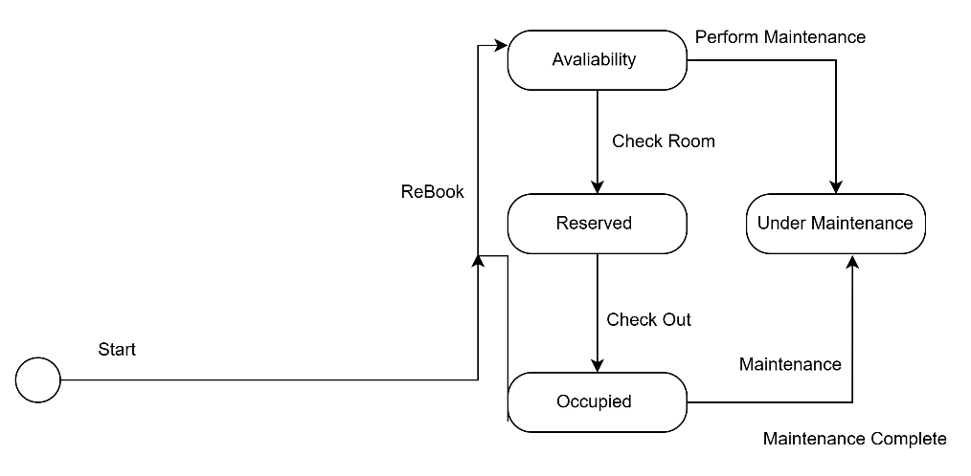

Task 3
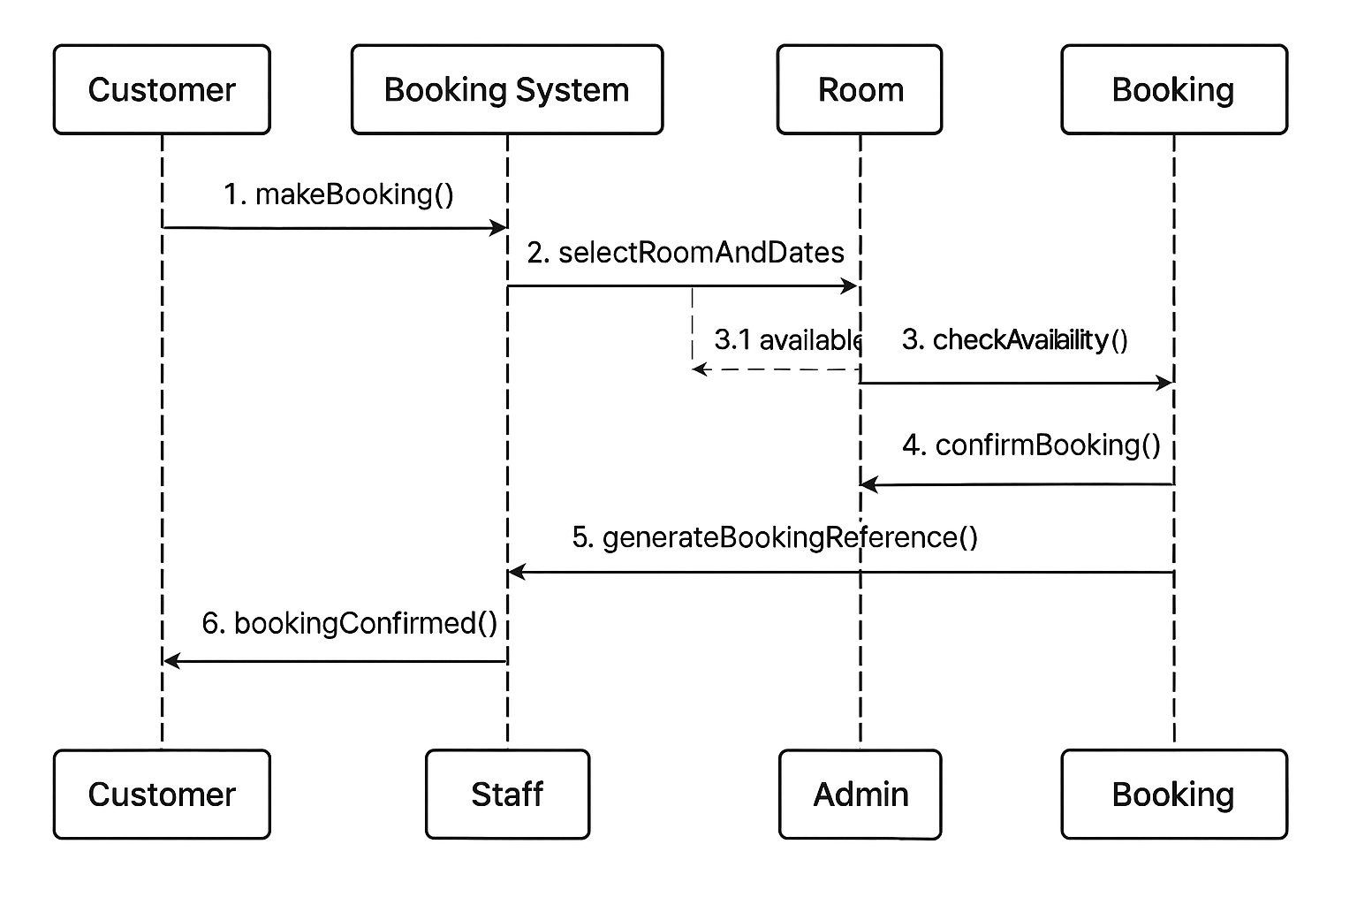
Task 4
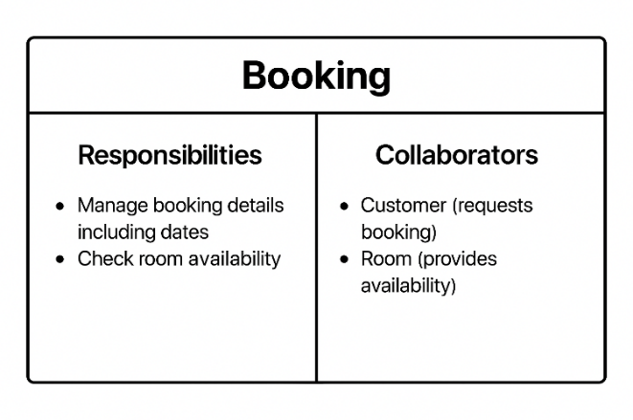

Appendix – Code Listings
Code List – W1-T1 (Android Studio Setup Confirmation
Code List – W2-T3 (SQLite Table Creation
Code List – W4-T1 (Java Method Critique)
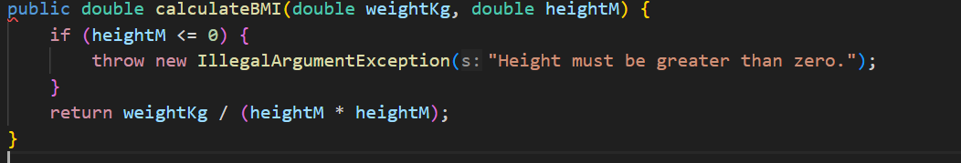
Code List – W5-T2 (Class Diagram Mapping
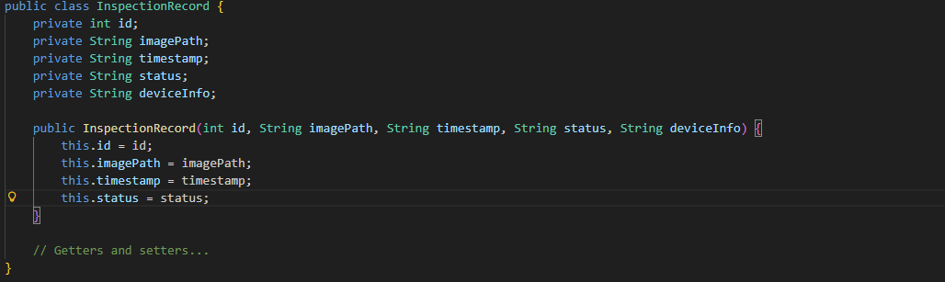
Code List – W6-T2 (Sequence Diagram Mapping)
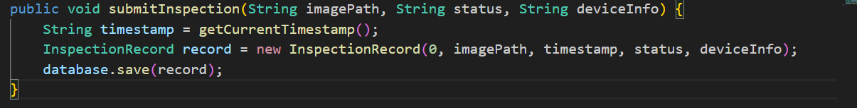
References
Microsoft Copilot. (2025, November 18). Microsoft Copilot. https://copilot.microsoft.com
This Assignment Used Generative AI in the following ways: Brainstorming, Planning Feedback and Editing

